**Robinhood Analyzing Technical Analysis**

Michael Cultrera

Colorado State University Global

MIS581: Capstone – Business Intelligence and Data Analytics

Dr. Justin Bateh

March 27, 2022

**ABSTRACT**

This section of the project will be completed in week eight.

**INTRODUCTION**

Robinhood Markets, Inc. is an American financial service company with a popular trading platform specialized for mobile devices. Robinhood has quickly gained popularity with younger investors, but it has also gained notoriety in the industry. Robinhood popularized trading on mobile devices, fractional share purchases, and commission-free trading. Roberts (2020) points out that Robinhood’s strategy of bringing in an ignored population segment to investing is not new. Charles Schwab lowered commissions and advertised to the “everyman” in the 1970s to great success.

Robinhood has faced criticism from traditional investors and firms that denounce the expansion of the investor class as many inexperienced investors will be taken advantage of. Robinson and Gopal (2021) explain that many critics point to the brightly colored app, animated confetti, and promotions as a “gamification” of investing. The younger investors that utilize Robinhood are generally users of social media as well. Social media has many influencers promoting the use of technical analysis and confident pricing predictions for stocks and cryptocurrencies.

Ayala, García-Torres, Noguera, Gómez-Vela, and Divina (2021) explain that technical analysis “TA” is using historical price data to find patterns and predict the future price movements of a stock or index. It is an alternative to fundamental analysis which evaluates stock prices based on the fundamentals such as earnings, competitors, and leadership. Mainfinex (2019) explains that TA relies on a few key principles. The first is that stock or crypto price history repeats itself with short and long-term trends. Patterns and trends apply to many different types of financial instruments as they are based on market psychology. Essentially, the traders’ emotions and likely responses are predictable as the price fluctuates.

The effectiveness of TA is compelling as it is relatively easy to find examples of price patterns repeating; however, there are many different TA indicators and patterns. Fidelity’s (2022) technical indicator guide lists information on over sixty different indicators. Of all these indicators, there is virtually always at least a handful that will point to a particular narrative. If an analyst would like to see a stock move up in price, there will virtually always be an indicator they can point to for confirmation.

A second limitation is that there are many choices made by a pricing analyst critical to the prediction outcome. On social media, it is easy to find different influencers looking at the same price chart but assigning different patterns with conflicting predictions. When reading a pricing chart, there are decisions the analyst makes such as when is the beginning time frame, should extraordinary events such as wars or recessions be included or ignored, and should a short-time frame or long-time frame pricing chart be used? All of these decisions can result in conflicting predictions with biased prognosticators always able to tell the price story with the ending of their choice.

**OBJECTIVES**

The business objective for Robinhood is to present clear and reliable research on some of the most common TA indicators and their relationship with trading asset price movements with the intent of publishing the information to its user base. Robinhood is not looking to leverage any potential windfall of discovering a successful trading strategy, but rather to attract new investors to their platform and retain the business of current investors.

The overarching aim of this research project is to analyze and understand the statistical relationship between three of the most common TA indicators and the subsequent price movement of tradeable assets such as stocks, indices, and cryptocurrencies.

The objectives of this project are:

* To simulate historical trading activity from a moving average crossover strategy and compare results with a simple buy and hold strategy
* To identify volume and pricing trends in historical data and assess their subsequent price fluctuations
* To generate candlestick pricing charts and identify common chart patterns and assess their subsequent price fluctuations

**OVERVIEW OF STUDY**

This project will analyze the pricing and volume trade data on ten of the largest stocks, ten of the largest cryptocurrencies, and ten of the most utilized stock indices. The study will attempt to identify any statistical relationships between TA indicators and subsequent price movements. The project will include three distinct analyses, each considering a separate type of TA indicator. The project will leverage Python and the Scipy, Plotly, TensorFlow, and Scikit-learn libraries.

**RESEARCH HYPOTHESIS**

This project consists of three separate analyses. The general hypothesis for the entire project is as follows:

H0: There is no statistical relationship between TA indicators and future price movements for traded assets.

H1: There is at least one statistical relationship between TA indicators and future price movements for commonly traded assets.

Each of the three separate analyses will address separate null and alternative hypotheses more detailed and specific to the particular analysis. The first analysis to be explored involves identifying and testing if a buy and sell strategy derived from moving average crossovers performs statistically different than a simple buy and hold strategy. A two-sample two-tailed t-test will be performed here because if the buy and sell strategy produces significantly worse profit, then a trader could quite easily flip the strategy to capture profit. The comparison of means will be performed with a t-test or Wilcoxon-Mann-Whitney test depending on the sample size and normality of the samples.

Here are the hypotheses for this first analysis:

H0: The mean profit from a buy and sell moving average crossover strategy and a buy and hold strategy are equal.

H1: The mean profit from a buy and sell moving average crossover strategy and a buy and hold strategy are different.

The second analysis involves identifying three-day volume and price trends and assigning them to potentially one of four dummy variables (D1, D2, D3, D4) for a regression model predicting a future price relative to the current price. This is the proposed linear regression model with P representing the percentage increase or decrease from the current price:

P= 0 + 1D1 + 2D2 + 3D3 + 4D4 + 

H0: j = 0

H1: j ≠ 0

The third analysis involves training a neural network to identify common TA chart patterns and assigning them to six dummy variables (C1, C2, C3, C4, C5, C6) for a regression model predicting future price relative to the current price. This is the proposed linear regression model with P representing the percentage increase or decrease from the current price:

P= 0 +1C1 + 2C2 + 3C3 + 4C4 +5C5 +6C6 + 

H0: j = 0

H1: j ≠ 0

If any of the three null hypotheses are rejected, then the more generalized null hypothesis for the entire project can be rejected as well.

**LITERATURE REVIEW**

Ayala, García-Torres, Noguera, Gómez-Vela, and Divina (2021) analyzed stock market price movements along with the Triple Exponential Moving Average (TEMA) and Moving Average Convergence Divergence (MACD). They incorporated machine learning algorithms into the technical indicators to create a hybrid model. The hybrid model outperformed the model based only on TA using artificial neural networks and linear regression. This research will expand the scope beyond stocks into cryptocurrencies, and will avoid using neural networks as the complexity and opaqueness of the model would not be in line with Robinhood’s goals of creating a clear and understandable model for its users.

Teodor and Bogdan (2015) explored the use of TA with the foreign exchange markets. Their study showed how the incorporation of TA can be used to better identify potential risk and how to handle that risk with particular trades. In their case study, they merged many different TA indicators, but this research project will be isolating different TA indicators to better assess their individual performance capabilities.

Stanković, Marković, and Stojanović (2015) studied the efficacy of TA modeling for stock indices of emerging markets. In addition to the TA indicators, they incorporated a Least Squares Support Vector Machines learning algorithm. They found their hybrid model outperformed simple buy-and-hold strategies and models based solely on the TA indicators. Their research was limited to small emerging markets in Southeast Europe.

Wang, Xu, and Zheng (2018) also leveraged a machine learning technique with TA indicators to produce an effective price prediction model for the Chinese stock market. Their work also incorporated market sentiment measures based on collected textual data from Chinese social media. Their work is an important merging of TA and sentiment analysis, but the model was only focused on the Chinese market and results in a complicated model that Robinhood users would struggle to understand.

Yıldırım, Toroslu, and Fiore (2021) studied the efficacy of a pricing model with TA indicators for the foreign exchange market. They also incorporated macroeconomic variables such as inflation and the Federal Reserve funds rate. Traditionally, the macroeconomic indicators are only considered relevant to fundamental market analysis and not TA. Their analysis concluded that both TA and fundamental market indicators can be successfully leveraged to train a neural network model, but their best results were found when they created separate neural models and then applied a decision matrix afterward to determine the optimal course of action.

There have been many studies focusing on predicting price movements in financial markets through the use of technical analysis. Most studies are focused on utilizing complex machine learning algorithms for higher predictability. Many also add alternate predictor variables such as market sentiment and fundamental analysis. Most studies are able to beat control strategies indicating there is value for investors to pursue leveraging analytical models.

**RESEARCH DESIGN**

**Methodology**

This research will be done in the quantitative tradition utilizing scientific or hypothetico-deductive methods. O’Leary (2021) explains that this methodological approach allows for scientific objectivity to be maintained. General exposure to the financial markets and TA influencers on social media inspired the general research questions leading to testable hypotheses. Online pricing data will be gathered and analyzed using statistical processes to better understand key variable relationships.

**Methods**

This research will utilize a randomized sample selection of large-cap stocks, indices, and cryptocurrencies. While a more complete and encompassing analysis of all tradeable asset classes including penny stocks and small market cryptocurrencies may lead to a better understanding of TA’s overall applicability, the larger market capitalization assets are by definition being traded more heavily by investors. If Robinhood published research on randomly selected micro-cap stocks, then many customers would balk at the applicability of the research to major stocks and may even suspect Robinhood nefariously choosing particular assets and disregarding the research as a result. Lastly, Robinhood’s cryptocurrency offerings are restricted to large market cap coins, so studying small market cap coins would not benefit Robinhood customers and may even drive them to a competitor with a larger offerings portfolio.

The data gathered is historical price and volume trading data. The secondary data will be sourced from Yahoo Finance but is widely available and verifiable through multiple sources. The data is pricing data based on supply and demand, so there are no partiality or bias concerns. Some descriptive statistics will be used to describe the data and assess normality, but most of the analysis will be based on inferential statistics.

**Limitations**

The trading markets are infamously difficult to predict as there are numerous price factors in the evolving financial markets, and investors need to understand that past successful strategies may no longer be effective. This is why the SEC requires financial institutions to state that past performance does not guarantee future results in advertisements. Kuo-Ping, Yung, and Hahn-Ming (2014) explain that financial time series are hard to forecast due to the non-stationary and non-linear nature with excessive noise.

The vast amount of TA indicators and multiple time frame choices to utilize make it impossible for any single study to assess TA performance in its entirety. It is not uncommon for different TA forecasters to assign contrary indicators to the same price chart. Additionally, there are thousands of tradeable assets. This project focuses on a sample of the largest and most popular stocks, indices, and cryptocurrencies. There is the potential that the results for these large assets are different from smaller assets. The project is still worth pursuing as it addresses some of the most commonly utilized indicators, and provides a clear and methodical approach for investors to reference as a baseline.

**Ethical considerations**

As a financial institution, Robinhood collects a wide range of extremely sensitive and private information from its customers including social security numbers and income information. This research project is not accessing any of this sensitive information and is relying solely on public information, so there is no risk of a data leak. The primary ethical consideration for this project is ensuring that the limitations are clearly articulated to avoid brash investors from irresponsibly over-relying on the results and making irresponsible financial decisions.

**FINDINGS**

**Moving Average Crossover Strategy**

The first section of the analysis identified and analyzed the profitability of a moving average crossover strategy compared with a simple buy-and-hold strategy. Figure 1 in the Appendix outlines how the moving average crossover strategy provides buy and sell signals when a shorter-term moving average crosses a longer-term moving average. Six different sets of moving averages were used on the total asset population. The timeframes used for the models were 5/10 days, 10/20 days, and 20/50 days. These timeframes were assessed by a simple moving average and a weighted moving average that progressively weighs recent price movements more which provides higher sensitivity to recent price fluctuations.

The crossover strategy provides iterative buy and sell signals. To assess how a crossover strategy compares with a buy and hold strategy, the price at a sell signal is compared with the price at the subsequent buy signal. If the price at the subsequent buy signal is higher than the former sell signal, then the crossover strategy failed and the investor would have been better off simply holding the asset, particularly if you incorporate transaction costs which this research did not attempt to evaluate. In hindsight, it is easy to see these crossover strategy failures as a result of a too sensitive or too insensitive moving average choice, but this analysis demonstrates there is no clear model that works consistently.

Figure 2 in the Appendix shows the results of each model compared with a buy-and-hold strategy. The results are similar for each model with either very similar performance or slightly worse performance than a buy and hold strategy. The visualized results are helpful, but a t-test is required to determine if the results indicate a statistical difference between the two strategies. Figure 3 in the Appendix shows the mean difference and t-test p-value for the six different models. The medium (10/20 day) and long (20/50 day) term models had p-values above 0.05 indicating the null hypothesis is unable to be rejected. The short (5/10 day) term models had p-values below 0.05, so the null hypothesis is rejected. The crossover strategy produces profitability statistically different from a buy and hold strategy, however, the results are worse for the crossover strategy. The results of this analysis conclude that investors should not consider moving average crossover strategies for their investments, with the exception of potentially flipping the buy and sell signals on a short-term model, but the difference was limited to only 1%.

**Price and Volume Trends**

The second section of the analysis was focused on identifying and analyzing pricing and volume three-day trends. Murphy (1999) explained that one of the six core tenets of technical analysis published by Charles Dow is that volume must confirm a price trend. Essentially, an expansion or growth in volume indicates strength and validity to a price trend. In particular, if there is a large positive swing in price with a substantial increase in volume, then it is believed this bodes well for future price trends as the increase in volume indicates increasing enthusiasm. On the contrary, a large positive swing in price accompanied by decreasing volume indicates a limited enthusiasm which may face price resistance soon. Similar assumptions are made on negative price swings. Essentially, the volume acts as a weight for the significance of the price movement on future price trends.

If the price and volume sequentially increased or decreased three days in a row, then the trend was categorized into four buckets: price up/volume up, price down/volume up, price up/volume down, and price down/volume down. Figure 4 in the Appendix shows the number of three-day windows analyzed and categorized for each (stock, index, and crypto) and all of the asset classes. Across all three asset classes, over 73 thousand three-day windows were assessed. Of those, only 2,247, or about 3%, were classified into one of these four buckets.

The four trend categories were then utilized as dummy variables in a linear regression model predicting future price change. All of the non-classified three-day records were included in the model and represented by the constant coefficient, 0, in order toavoid multicollinearity. Suleiman (2015) warns against the ‘dummy variable trap’ in which a dummy variable is created for each potential category guaranteeing perfect multicollinearity. Linear regression models were prepared for each and all asset classes for a total of four different samples. Each sample was analyzed against three different future price points (5/10/20 days) requiring a total of twelve different regression models. With the exception of the stocks-only model predicting price change ten days in the future, at least one price/volume trend category was identified as statistically significant with a p-value less than 0.05. This indicates that the null hypothesis can be rejected as the regression coefficients are not equal to zero, and investors should certainly consider pricing and volume trends in their investment decisions.

Figure 5 in the Appendix, shows each coefficient that was identified as statistically significant. The coefficient value differed significantly across the models. Generally speaking, the trends with increasing volume were more likely to be significant which indicates investors should attribute little value to pricing trends with decreasing volume. The cryptocurrency-only models produced noticeably higher coefficients in absolute terms. This is to be expected as the cryptocurrency market sees significantly higher volatility than the stock market.

It is important to understand that these results are based on pricing change percentages. Highly volatile markets will average higher price changes when evaluating small price windows due to the adjusted denominator in the percentage change calculation. To illustrate this, consider a simple example of a $100 priced asset. If the asset increases 50% to $150 and then decreases 33.3% back to $100, the mean price change was 8.3% ((.5-.33)/2) despite the asset having no price change when viewing with a longer time frame. Consider a similar example in a less volatile market. If a $100 asset increases 10% to $110, then decreases 9.1% back to $100, the mean price change was only 0.5% ((.1-.091)/2).

**Chart Patterns**

The third section of the analysis focused on six common chart patterns identified when viewing pricing charts. Fidelity Investments (2020) outlines bullish chart patterns including the double bottom, inverted head and shoulders, and cup and handle which this research covered. The reverse of these are the bearish versions called double top, head and shoulders, and inverted cup and handle which are also covered in this research. A standard template for each of these patterns was developed. Based on these standard templates, eight hundred simulated variations were produced utilizing a normally distributed randomization multiplier. Figure 6 in the Appendix shows the standard templates as well as the first hundred simulated price charts stacked together. The eight hundred simulated pricing charts were used as the training set for a Convolutional Neural Network image classifier in Keras. The eight hundred simulated charts were combined with eight hundred random walk pricing charts. A ten count sample can be found in Figure 7 in the Appendix.

A separate neural network model was trained for each of the six chart patterns being analyzed. Each model was trained on eight hundred simulated price chart images with half representing a positive chart pattern and half being a negative random walk pattern. Each model was then tested on four hundred similarly produced chart images. The accuracy results of each model can be found in Figure 8 in the Appendix. Every model achieved an accuracy of 99% or above on the testing datasets.

The actual price data was then utilized to produce real pricing charts. The chart pattern mining involved taking price snapshots every three days for three different timeframes: 20, 35, and 50-day spans. These generated pricing charts based on real data were then input into each of the six neural network models. Over seventy thousand pricing charts were produced and analyzed by each of the six models. If a model identified the designated pattern in any of the three timeframes, then that day was marked as an identified chart pattern. The identification statistics for each of the six models differentiated by asset class can be found in Figure 9 in the Appendix. All six patterns were identified in the real-world price charts, but some patterns were found more regularly than others. In particular, the inverted cup and handle pattern was more likely to be identified than all of the other patterns combined. The cup and handle and inverted cup and handle pattern templates and training samples were identically produced with the same randomization multiplier, but the cup and handle pattern was rarely identified.

The results of the neural network image classifier models were utilized as dummy variables in a linear regression model predicting future price change. An absence of a chart pattern was incorporated into the model and represented by the constant coefficient, 0, in order toavoid multicollinearity. Linear regression models were prepared for each and all asset classes for a total of four different samples. Each sample was analyzed against three different future price points (5/10/20 days) requiring a total of twelve different regression models. The statistically significant coefficients of each model can be found in Figure 10 in the Appendix. With the exception of the stocks-only model predicting price change twenty days in the future, at least one chart pattern was identified as statistically significant with a p-value less than 0.05. This indicates that the null hypothesis can be rejected as the regression coefficients are not equal to zero, and investors should consider some of these chart patterns in their investment decisions. It is worth noting that the magnitude and direction of the pricing change varied across the different asset classes, so investors should not blindly assume these chart patterns are universally applicable.

The technique developed in this research evaluates all assets and classes together while allowing individual assets or classes to be separated and assessed individually. All models evaluated price change by percentage rather than absolute terms so assets trading at different price points can be evaluated together. Steps are taken to ensure there is no misalignment of key data points as all the information is grouped together, but by congregating the data together, the models are highly efficient and scalable to additional assets being incorporated in future research.

**CONCLUSION**

This research considered three very different types of TA indicators including moving averages, price and volume trends, and chart patterns. All three types of indicators produced statistically significant results, although the moving average analysis showed minimal results that are likely not applicable in real-world use with transaction costs. For both the pricing and volume trends and the chart patterns, there were instances of the data corroborating the general bearish or bullish expectation from these TA indicators. The magnitude and consistency of these indicators are not universally applicable to all asset classes and time frames, so they should not be followed blindly by investors. Based on the statistical models, the general null hypothesis can be rejected as there are statistical relationships between some TA indicators and future price movements for the tradeable assets considered in this analysis. Robinhood should present these findings to its customers through an easy to understand interface that articulates the unbiased nature of the research as well as the multifaceted results with reminders of the risks of relying on past performance for future price movements.

**RECOMMENDATIONS**

The artificial neural network models identifying chart patterns were trained on random walk price charts for the control or negative samples. To further refine the models’ capability of distinguishing chart patterns, researchers should consider intentionally constructing pricing charts that are closer to the particular chart patterns. For example, a ‘triple-top’ pattern with three consecutive peaks reaching similar heights could be constructed and introduced into the head and shoulders model as a false example. By including this in the false sample group, the model can more effectively weigh the significance of the extended middle peak height in the head and shoulders pattern.

For the business purposes of providing an unbiased and data-driven perspective on commonly referenced chart patterns, it was important for Robinhood to base this research on pre-determined patterns. If Robinhood or other researchers seek to identify optimal financial results, it is recommended that the scope of chart patterns be determined through an unsupervised learning algorithm such as k-means. Kuo-Ping, Yung, and Hahn-Ming (2014) have shown that such models can outperform well-regarded mutual funds.

As previously outlined, there is virtually a limitless amount of TA assessments possible due to technical indicator variations. Many people will dispute some of the choices such as time horizon and model sensitivity used in this research. An advised subsequent step for Robinhood is to develop a flexible and fully interactive interface based on this research that allows the end-user to adjust the parameters and patterns and immediately see the historical performance. Beyond rebutting expected criticisms of the research model, this will provide a unique benefit to Robinhood customers further differentiating them from their competitors.

**REFERENCES**

Ayala, J., García-Torres, M., Noguera, J. L. V., Gómez-Vela, F., & Divina, F. (2021). Technical analysis strategy optimization using a machine learning approach in stock market indices. *Knowledge-Based Systems*, *225*. <https://doi.org/10.1016/j.knosys.2021.107119>

Fidelity Investments (2020). Identifying chart patterns with technical analysis. <https://www.fidelity.com/bin-public/060_www_fidelity_com/documents/learning-center/Deck_Chart%20patterns.pdf>

Fidelity Investments (2022). Technical indicator guide. <https://www.fidelity.com/learning-center/trading-investing/technical-analysis/technical-indicator-guide/overview>

ForexAbode.com (n.d.) Moving averages trading strategies. <http://www.forexabode.com/forex-school/technical-indicators/moving-averages/moving-averages-trading-strategies/>

Kuo-Ping W., Yung P. W., & Hahn-Ming L. (2014). Stock Trend Prediction by Using K-Means and AprioriAll Algorithm for Sequential Chart Pattern Mining. *Journal of Information Science & Engineering*, *30*(3), 653–667.

Mainfinex (2019) The basics of technical analysis for cryptocurrency trading. <https://medium.com/@mainfinex/the-basics-of-technical-analysis-for-cryptocurrency-trading-38289893045c>

Murphy, J. J. (1999). *Technical analysis of the financial markets: A comprehensive guide to trading methods and applications*. Penguin.

O’Leary, Z. (2021). *The essential guide to doing your research project.* (4th ed.). SAGE Publishing.

Roberts, J. J. (2020). Stealing (market share) from the rich*. Fortune, 182(4),* 102–108.

Robinson, M., & Gopal, P. (2021). The sheriff wants a word with Robinhood*. Bloomberg Businessweek, 4691,* 27–29*.*

Stanković, J., Marković, I., & Stojanović, M. (2015). Investment strategy optimization using technical analysis and predictive modeling in emerging markets. *Procedia Economics and Finance, 19*, 51–62. <https://doi.org/10.1016/S2212-5671(15)00007-6>

Suleiman, A. A. (2015). Analysis of multicollinearity in multiple regressions. *Int. J. Adv. Technol. Eng. Sci*, *3*, 571-578.

Teodor, H., & Bogdan, A. (2015). Risk dimensioning through technical analysis on the forex market: case study. *Procedia Economics and Finance, 32*, 1700–1706. <https://doi.org/10.1016/S2212-5671(15)01497-5>

Wang, Q., Xu, W., & Zheng, H. (2018). Combining the wisdom of crowds and technical analysis for financial market prediction using deep random subspace ensembles. *Neurocomputing, 299,* 51–61. <https://doi.org/10.1016/j.neucom.2018.02.095>

Yıldırım, D. C., Toroslu, I. H., & Fiore, U. (2021). Forecasting directional movement of forex data using LSTM with technical and macroeconomic indicators. *Financial Innovation*, *7*(1), 1–36. <https://doi.org/10.1186/s40854-020-00220-2>

**APPENDIX**

**Figure 1.**

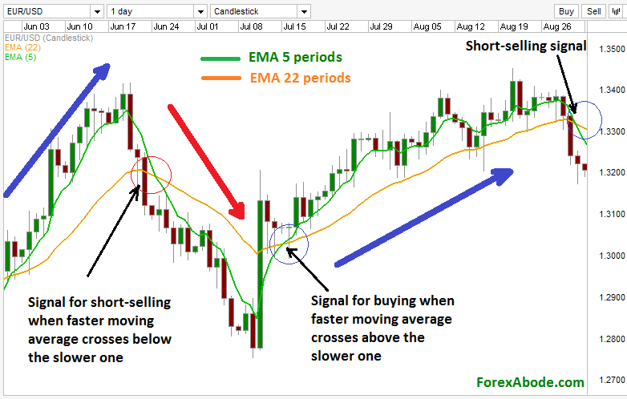

*Moving Average Crossover Strategy Buy/Sell Signals*

*(source: http://www.forexabode.com/forex-school/technical-indicators/moving-averages/moving-averages-trading-strategies/)*

**Figure 2.**

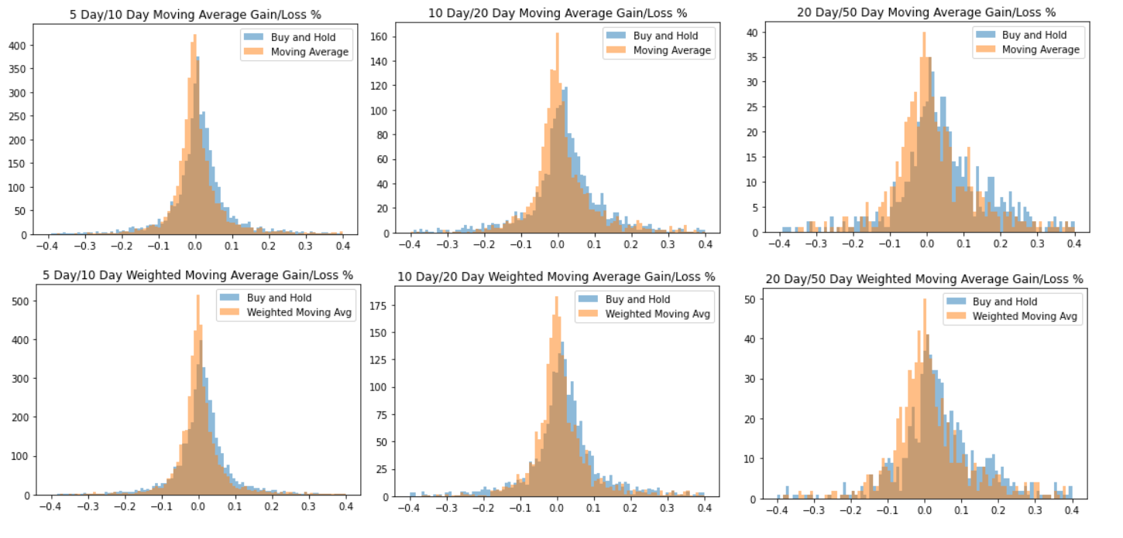

*Gain/loss percentages following the six different crossover strategies for all asset classes.*

**Figure 3.**

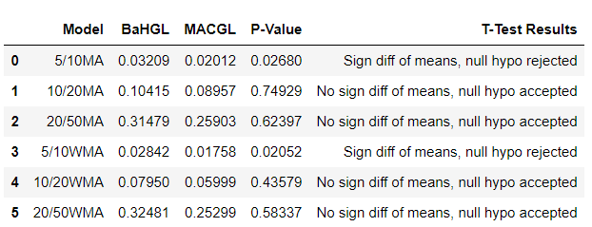

*T-test and mean gain/loss results across six different moving average strategies for all asset classes.*

**Figure 4.**

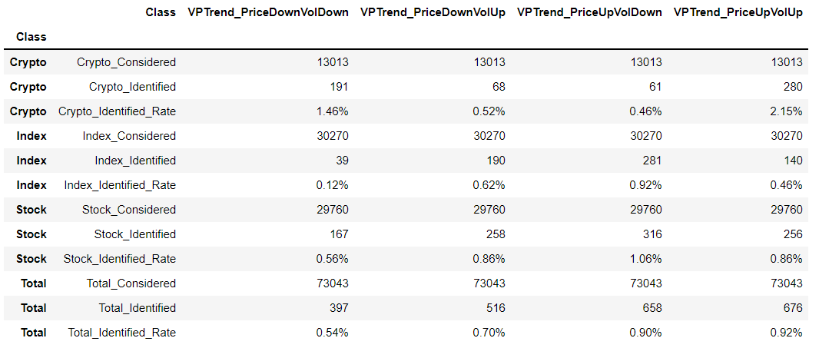

*Descriptive Statistics on volume and pricing trends identified in the pricing data for each and all asset classes.*

**Figure 5.**

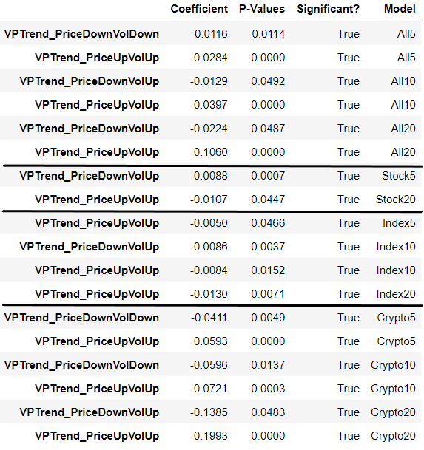

*Regression results for volume and pricing trends identified in the pricing data for each and all asset classes for 5, 10, and 20-day future price changes. The results are limited to only statistically significant (p<0.05) coefficients.*

**Figure 6.**

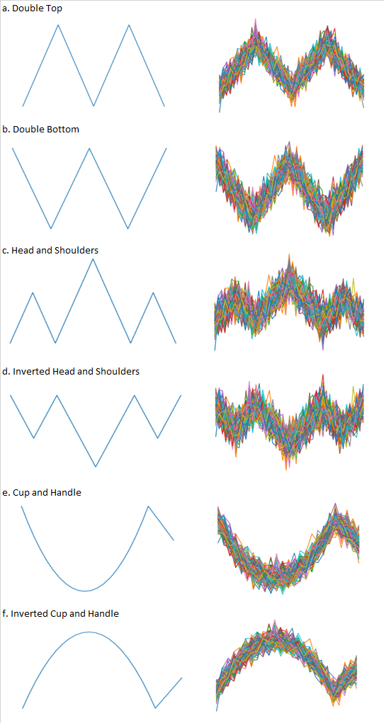

*The six different chart patterns analyzed. The left column represents the template pricing chart used for the pattern. The right column displays 100 randomized variations of the template used in the training set for the neural network model.*

**Figure 7.**

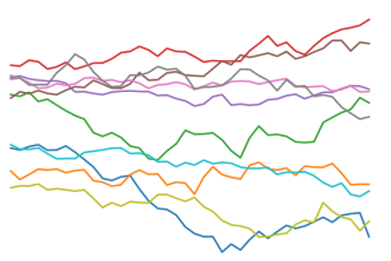

*A sample of ten different random walk pricing charts used to train the absence of a pricing chart pattern.*

**Figure 8.**

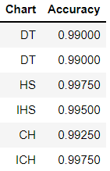

*The accuracy results of each chart pattern model based on the testing group (200 simulated chart patterns with randomized variations and 200 random-walk price charts).*

**Figure 9.**

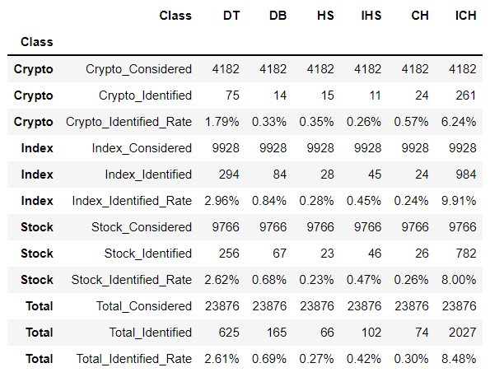

*Descriptive Statistics on chart patterns identified in the pricing data for each and all asset classes.*

**Figure 10.**

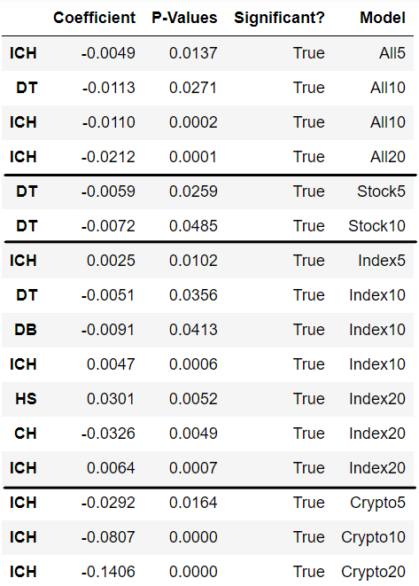

*Regression results for chart patterns identified in the pricing data for each and all asset classes for 5, 10, and 20-day future price changes. The results are limited to only statistically significant (p<0.05) coefficients.*